2010 DHS Year 6 H2 Chemistry Preliminary Exam Paper 1 – Worked Solutions

1 Answer: C
Topic: mole concept

Solution:
C₆H₅COCH₃ ≡ CHI₃
n_{CHI3} = 12.0/394 = 0.0304 = n_{phenylethanone}
mass of C₆H₅COCH₃ = 0.0304 x 120= 3.65 g

2 Answer: A
Topic: Mole Concept/Halogen Derivatives

Solution:
CH₃CH₂OH + Br– → CH₃CH₂Br + OH–
Ethanol is the limiting reagent.
mole of bromoethane = 1/10 mol
mass of bromoethane = 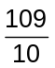g

3 Answer: D
Topic: Atomic Structure

Solution:
Determine the difference between each successive IE. Use the biggest jump and determine the Group number. In this question, the biggest is between number 6 & 7. The element is a Group VI element but according to the Data Booklet, Te is more likely to the answer rather than O.

4 Answer: C
Topic: Atomic structure

Solution:
Electron is removed from 4s orbital first.

5 Answer: D
Topic: Chemical bonding

Solution:
Dative bonding between BH₃ and (CH₃)₃N molecule.

6 Answer: D
Topic: Ideal Gas

Solution:
Using the equation pv = nRT, for a fixed mass, pv is always a constant no matter how p changes.

7 Answer: C
Topic: Chem Eqm

Solution:
When enthalpy change (ΔH) is zero, it means neither the forward nor backward is exothermic/endothermic, thus changing temperature will not shift position of equilibrium. Hence K_{c} remains unchanged despite a change a temperature.

8 Answer: B
Topic: Energetics

Solution:
The question has already state that the folding of the protein is spontaneous and therefore ΔG is negative. Folding of a protein will cause the protein to be arranged in a specific manner thereby lowering entropy resulting in ΔS being negative. The formation of the various stabiling forces of attraction causes the ΔH to be negative to reflect bond formation.

9 Answer: C
Topic: Energetics (Thermochemistry)

Solution:
Zinc (0.2 mol) is the limiting reagent.
ΔH = = 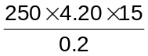
= – 78.8 kJ mol^{–1}

10 Answer: C
Topic: Redox

Solution:

No. of mole of CuSO₄.5H₂O
= 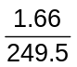= 0.00665
2Cu²⁺ ≡ I₂ ≡ 2S₂O₃^{2–}
Volume of S₂O₃^{2–} = 0.00665/ 0.15
= 0.044 dm³

11 Answer: A
Topic: Ionic equilibrium

Solution:
[H⁺] will decrease as V increases hence pH will increase. Final pH achieved will be 7 as [H⁺] will be no less than 10^{–7} mol dm^{–3}.

12 Answer: B
Topic: Ionic equilibrium
Solution:
K_{sp} of AgBr = [Ag⁺][Br–] = 5 x 10^{–13}
[Ag⁺] = (5 x 10^{–13})^{1/2} = 7.07 x 10^{–7}
(< 10^{–6} mol dm^{–3} but > 10^{–7} mol dm^{–3})

13 Answer: C
Topic: Kinetics

Solution:
Slow step requires the highest E_{a}.
Exothermic reaction = negative ΔH
Endothermic reaction = positive ΔH

14 Answer: D
Topic: Kinetics

Solution:
Let half–life of Q be x and half life of P be 2x.
time taken after 2 half lives of P = 4x
= time taken after 4 half lives of Q.
Let number of atoms of P be y and number of atoms of Q be 4y.
For Q, 4y→2y→y→1/2y→1/4y
For P, y→1/2y→1/4y

15 Answer: C
Topic: Periodic Table

Solution:
For barium and sodium, chloride cannot be readily hydrolysed. The oxides of phosphorus have simple molecular structure.

16 Answer:
Topic: Periodic Table

Solution:
P is Si, Q is Na and R is Mg. Atomic radius increases from right to left of period.

17 Answer: D
Topic: Group II

Solution:
Lower final mass on graph means more easily decomposed. Ease of decomposition decreases down the group.

18 Answer: C
Topic: Group VII

Solution:
Cl– + H₂SO₄ → HCl + HSO₄–
Br– + H₂SO₄ → HBr + HSO₄–
2HBr + H₂SO₄ → Br₂ + 2H₂O + SO₂
I– + H₂SO₄ → HI + HSO₄–
2HI + H₂SO₄ → I₂ + 2H₂O + SO₂

19 Answer: C
Topic: Transition elements

Solution:
High electrical conductivity indicates elements X and Y are metals. High m.p. and density for Y indicates it’s a transition metal.

20 Answer: B
Topic: Intro to Organic Chem, Alkenes, R–X

Solution:
Criteria for cis–trans isomerism:
1. Restricted rotation about C=C
2. Two different substituent groups on each double–bond C.
C ✗: hydrolysis by H⁺ produces –COOH
(from –CN)
D ✗: 6 mols of H₂ for reduction

21 Answer: B
Topic: Intro to Organic Chem

Solution:
RCOOH (carboxylic acid) and RCOOR’
(ester) are structural (functional group)
isomers.
E.g. C₃H₆O₂ can be:
CH₃CH₂COOH vs CH₃COOCH₃

22 Answer: C
Topic: Alkene

Solution:
CH₂=CH₂ + HBr → CH₃CH₂Br
Electrophilic addition involving a HX (e.g. HCl or HBr) forms a carbocation intermediate, which is an electrophile (+).
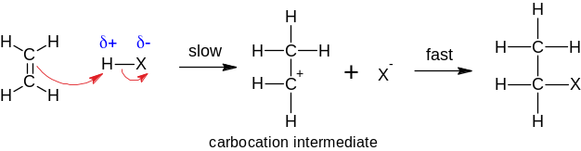

C ✗: Intermediate does not contain Br.
D ✗: shape is tetrahedral about C in methyl
(–CH₃) group, hence not planar.

23 Answer: D
Topic: Alkene, Arene ⇒ application

Solution:

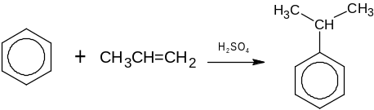
⇒ alkene group becomes C–C and gains H
Thus, apply the same ‘reaction’:

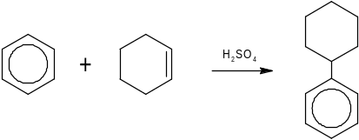

24 Answer: C
Topic: Arenes

Solution:
Electrophilic substitution and electrophilic addition can take place.

25 Answer: A
Topic: Arenes

Solution:
Since only 4–nitrodeuteriobenzene is required after the reaction, the incoming nitro group can only occupy a specific position with respect to deuterium. Hence the proportion should be 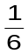.

26 Answer: B
Topic: Alcohol

Solution: After dehydration, one of the alkene will have cis–trans isomer while the other will not have.

27 Answer: D
Topic: Halogen Derivatives + Alcohols

Solution: Potassium dichromate oxidises primary alcohol in 2,4–D but no reaction with MCPA.

28 Answer: B
Topic: Carboxylic acid and derivatives

Solution: The nitrile contains three carbons including the –CN group. It will produce a three carbons carboxylic acid upon acid hydrolysis.
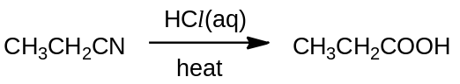

29 Answer: A
Topic: Nitrogen compounds

Solution:
The anion of the potassium salt acts as a nucleophile and attacks the halogenalkane in step 1. This is a nucleophilic substitution reaction.
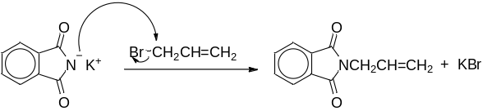
The product generated from step 1 will then be hydrolysed to carboxylic acid in a similar way as the hydrolysis of an amide.
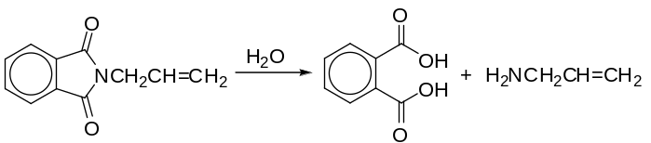

30 Answer: C
Topic: Carboxylic acid and derivatives

Solution:
A gives CH₃CH₂COO– Na⁺ + ND₃
B gives CH₃COOH + CH₃OH (D₂SO₄ is acting as catalyst.)
C gives CH₃CD₂ND₂
D gives (CH₃)₂CH=CH₂ + H₂O

31 Answer: B
Topic: mole

Solution:
1✓ C_{n}H_{2n} + (3/2 n)O₂(g) → nCO₂(g) + nH₂O(l)
nC : 1.5n O₂
⇒ every mol of C requires 1.5 mol of O₂
⇒ directly proportional
2✓ at r.t.p, H₂O is (l)
⇒ from eqn, gas produced is only CO₂ with volume equal to no. of C in alkane, since C_{n}H_{2n} ≡ nCO₂
3✗ nCO₂ ≡ nH₂O ⇒ not twice.

32 Answer: C
Topic: Chemical bonding

Solution:
1✗ BF₃ is simple molecular, AlF₃ is ionic.
2✓ Both have simple molecular structure.
3✓ Both have giant molecular structure.
33 Answer: B
Topic: Energetics

Solution:
3✗ Using the relationship ΔH_{latt} ∝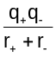, chlorine being more electronegative is not applicable in ionic compounds.

34 Answer: D
Topic: Electrochemistry

Solution:
1✓ In equilibrium (15 °C) means no current.
2✗ Above 15 °C, electrons flow from I to II.
3✗ Changing size of the electrode has no effect on the cell potential.

35 Answer: A
Topic: Transition elements

Solution:
CuCl₂ → Cu(OH)₂ → [Cu(NH₃)₄]²⁺ (G–– deep
blue solution) → Cu(OH)₂ (blue ppt) → CuCl₄^{2–}
(H—yellow–green solution)

36 Answer: C
Topic: Kinetics

Solution:
1✗ only for elementary reaction
2✓ 2nd order w.r.t Y as rate (gradient) 4 when [Y] doubles; 1st order w.r.t Z as half life is constant for [Z] against time graph.
3✓ zero order w.r.t X as it is a straight line graph for [X] against time.

37 Answer: A
Topic: R–X (halogenoalkane)

Solution:
(CH₃)₃SiCl+C₂H₅O– ⎯→ (CH₃)₃SiOC₂H₅+Cl–
⇒ recognise that R–Cl undergoes nucleophilic substitution reaction.
1✓ C₂H₅O– acts as nucleophile.
2✓ –Cl is substituted by C₂H₅O–.
3✓ CO bond in C₂H₅O– is not broken.

38 Answer: A
Topic: Intro to Organic Chem

Solution:
1,2, 3✓
Optical isomers (enantiomers):
• have identical chemical properties and physical properties.
• exception: rotate plane of polarised light in opposite directions.

39 Answer: B
Topic: Chem Bonding, practical skill

Solution:
Product should have lower boiling point than reactant in order to be distilled out.

1,2✓ CH₃CH₂Br and CH₃CHO (both with intermolecular vdw) has lower b.p than C₂H₅OH (intermolecular H–bond).
3✗ CH₂BrCH₂Br has higher b.p than ethene (a gas).

40 Answer: A
Topic: Integrated organic chemistry

Solution:
1✓ Hydroquinone is acidic (phenol) and will react with base to form salt and water.
2✓ If hydroquinone is able to reduce silver ions, it will also reduce KMnO₄ since Eº for MnO₄–/Mn²⁺ > Ag⁺/Ag
3✓ Silver ions are reduced by hydroquinone to silver metal.

1 | 2 | 3 | 4 | 5 | 6 | 7 | 8 | 9 | 10
C | A | D | D | D | D | A | B | C | C
11 | 12 | 13 | 14 | 15 | 16 | 17 | 18 | 19 | 20
A | B | C | D | C | A | D | C | D | B
21 | 22 | 23 | 24 | 25 | 26 | 27 | 28 | 29 | 30
B | C | D | C | A | B | D | B | A | C
31 | 32 | 33 | 34 | 35 | 36 | 37 | 38 | 39 | 40
B | C | B | D | A | C | A | A | B | A

